Optimizing inventory management for improving resource mobilization, growth and profitability of a retail pharmaceutical business

**Final submission report for the BDM capstone Project**

Submitted by

Name: BINAYAK BANERJEE

Roll number:21F2000510



IITM BS Degree Program,

Indian Institute of Technology, Madras, Chennai

Tamil Nadu, India, 600036

**Contents**

1. **Executive summary** -------------------------------------------------------------------------------4-5
2. **Organization background**----------------------------------------------------------------------5
3. **Problem statement**----------------------------------------------------------------------------------5
4. **Project timeline**----------------------------------------------------------------------------------------6
5. **Proof of originality**---------------------------------------------------------------------------------6-7
6. **Metadata and descriptive statistics**-----------------------------------------------------8-11
   1. Metadata-------------------------------------------------------------------------------------------------8-9
   2. Descriptive statistics----------------------------------------------------------------------------------10-11
7. **Detailed explanation of analysis process**-------------------------------------------11-15
   1. Data collection-------------------------------------------------------------------------------------------12
   2. Data cleaning and preprocessing----------------------------------------------------------------------12
   3. Inventory turnover ratio Analysis---------------------------------------------------------------------12
   4. Inventory Movement Categorization Analysis -----------------------------------------------------13
   5. ABC Analysis--------------------------------------------------------------------------------------------13
   6. Inventory risk assessment using stockout probabilities------------------------------------------13-14
   7. ABC-XYZ Analysis----------------------------------------------------------------------------------14-15
8. **Results and findings**------------------------------------------------------------------------------16-29
   1. Results and findings from inventory turnover ratio analysis------------------------------------16-18
      1. Inventory Turnover Ratio (ITR) Range Categorization--------------------------17
      2. Purchase and Sales Value------------------------------------------------------------17
      3. Capital Blockage Insights------------------------------------------------------------18
      4. Key findings----------------------------------------------------------------------------18
   2. Results and findings from inventory movement categorization analysis-----------------------18-22
      1. Item Category Distribution------------------------------------------------------------21
      2. Capital Blockage Contribution per Item---------------------------------------------21
      3. Rolling Capital Efficiency-------------------------------------------------------------22
      4. Net Capital Usage-----------------------------------------------------------------------22
      5. Sales and Profit Analysis--------------------------------------------------------------22
   3. Results and findings from ABC analysis------------------------------------------------------------22-23
      1. Item categories and capital blockage contribution---------------------------------23
   4. Results and findings from stockout probability distribution analysis----------------------------24-25
      1. Stockout probability distribution------------------------------------------------------25
      2. Key insights------------------------------------------------------------------------------25
   5. Results and findings from ABC-XYZ analysis----------------------------------------------------26-29
      1. Volume and stability insights----------------------------------------------------------28
      2. Value contribution by categories------------------------------------------------------29
      3. Percentage of items by volume and uncertainty-------------------------------------29
9. **Interpretation of results and recommendations**--------------------------------29-31
   1. Recommendations based on item categories--------------------------------------------------------29-30
      1. Non-moving items-----------------------------------------------------------------------29
      2. Slow-moving items----------------------------------------------------------------------29
      3. Fast-moving items---------------------------------------------------------------------29-30
      4. Remaining items-------------------------------------------------------------------------30
   2. Capital blockage reduction------------------------------------------------------------------------------30
      1. Priority Action---------------------------------------------------------------------------30
      2. Minimize Overstocking-----------------------------------------------------------------30
   3. Inventory Risk Management for Fast-Moving Items------------------------------------------------30
      1. Critical stockout prevention--------------------------------------------------------30
      2. Monitor low risk items--------------------------------------------------------------30
   4. ABC-XYZ analysis based strategies---------------------------------------------------------------30
      1. Automate replenishment for high value items-----------------------------------30
      2. Reduce overstocking in low value fluctuating items----------------------------30
      3. Dynamic pricing for fluctuating demand-----------------------------------------30
   5. Overall strategy---------------------------------------------------------------------------------------31
      1. Inventory efficiency-----------------------------------------------------------------31
      2. Resource mobilization--------------------------------------------------------------31
      3. Growth and profitability------------------------------------------------------------31

**List of Figures:**

* Figure 5.1: Letter from the organization (New Medica)--------------------------------------------------6
* Figure 5.2: Front view of the retail shop (New Medica)--------------------------------------------------7
* Figure 5.3: Inside view of the retail shop (New Medica)-------------------------------------------------7
* Figure 8.1: Item Distribution and Inventory Percentage-------------------------------------------------16
* Figure 8.2:Purchase, Sales, and Capital Blockage Comparison----------------------------------------18
* Figure 8.3: Category-wise item count----------------------------------------------------------------------19
* Figure 8.4: Percentage-wise representation of items across categories--------------------------------19
* Figure 8.5: Value analysis of categorized items-----------------------------------------------------------20
* Figure 8.6: Capital usage analysis across item categories------------------------------------------------20
* Figure 8.7: Capital blockage contribution per item--------------------------------------------------------21
* Figure 8.8: Percentage-wise analysis of slow-moving items with capital blockage contribution---23
* Figure 8.9: Fast-moving item distribution based on percentage probability of stockout-------------24
* Figure 8.10: Categorical distribution of fast-moving items based on stockout probabilities------25
* Figure 8.11: Value analysis across item categories of remaining items--------------------------------28

**List of tables:**

* Table 8.1 ITR Range Analysis by Item Category----------------------------------------------------------16
* Table 8.2: Criteria for item categorization of consolidated inventory data-----------------------------18
* Table 8.3: Category-wise item distribution and value analysis-------------------------------------------19
* Table 8.4: Capital flow analysis across item categories---------------------------------------------------20
* Table 8.5: Calculation of capital blockage contribution of slow-moving items------------------------22
* Table 8.6: Calculation of stockout probabilities across fast-moving items-----------------------------24
* Table 8.7: Significance of item categories in ABC-XYZ analysis---------------------------------------26
* Table 8.8: Distribution of items across categories----------------------------------------------------------26
* Table 8.9: Percentage-wise distribution of items across categories--------------------------------------27
* Table 8.10: Inventory management strategy matrix based on ABC-XYZ analysis--------------------27
* Table 8.11: Summary of value analysis of A, B and C categories---------------------------------------28

**List of Equations:**

* Equation 7.1:Inventory turnover ratio (ITR)----------------------------------------------------------------12
* Equation 7.2:Average inventory------------------------------------------------------------------------------12
* Equation 7.3: Cumulative capital blockage-----------------------------------------------------------------13
* Equation 7.4: Probability of item stockout------------------------------------------------------------------14
* Equation 7.5: Cumulative sales value------------------------------------------------------------------------15
* Equation 7.6: Population standard deviation----------------------------------------------------------------15
* Equation 7.7: Coefficient of variation -----------------------------------------------------------------------15

**Declaration Statement**

I am working on a Project titled “Optimizing inventory management for improving resource mobilization, growth and profitability of a retail pharmaceutical business”. I extend my appreciation to “**New Medica”** for providing the necessary resources that enabled me to conduct my project.

I hereby assert that the data presented and assessed in this project report is genuine and precise to the utmost extent of my knowledge and capabilities. The data has been gathered from primary sources and carefully analyzed to assure its reliability.

Additionally, I affirm that all procedures employed for the purpose of data collection and analysis have been duly explained in this report. The outcomes and inferences derived from the data are an accurate depiction of the findings acquired through thorough analytical procedures.

I am dedicated to adhering to the principles of academic honesty and integrity, and I am receptive to any additional examination or validation of the data contained in this project report.

I understand that the execution of this project is intended for individual completion and is not to be undertaken collectively. I thus affirm that I am not engaged in any form of collaboration with other individuals, and that all the work undertaken has been solely conducted by me. In the event that plagiarism is detected in the report at any stage of the project's completion, I am fully aware and prepared to accept disciplinary measures imposed by the relevant authority.

I understand that all recommendations made in this project report are within the context of the academic project taken up towards course fulfillment in the BS Degree Program offered by IIT Madras. The institution does not endorse any of the claims or comments.

Signature of Candidate: __________________

Name: BINAYAK BANERJEE

Date: 25-09-2024

1. **Executive Summary:**

New Medica, a retail pharmaceutical shop in Rishra, West Bengal, operates as a B2C business serving the local community. The business project analyses the inventory management system of New Medica, based on data-driven insights from purchase and sales transactions made available for the period of April 2023 to September 2023 with the focus on understanding purchase and sales patterns, inventory turnover, and stock levels.

The metadata obtained from purchase and sales transaction data along with inventory data of the months of the review period comprises the following key variables:

1. **Purchase Value:** The net purchase value after considering discounts and GST.
2. **Sales Value:** The net sales value generated from the item.
3. **OB Qty:** The opening balance of an item at the beginning of each month. This helps track the starting stock levels.
4. **CB Qty:** The closing balance of an item at the end of each month. This indicates the remaining stock levels.
5. **Expiry Date:** Indicates the expiration date of the purchased items for minimizing losses due to expired products.

With the aim to improve inventory management system in achieving proper resource allocation and improving profitability of the business, further analysis have been undertaken.

**Inventory Turnover Ratio (ITR)** is critical for assessing stock movement, capital blockage, and purchase-sales discrepancy.The analysis is performed on total items in the inventory to segregate items into five categories **(A, B, C, D, and E)** using ITR as the main variable. We find that Category A has the lowest turnover and highest capital blockage, while Category **E** has the highest turnover and capital efficiency. Category **A** items, comprising **52%** of inventory, are found to tie up **91%** of the capital, with a massive gap between purchase value **(₹13.74 lakhs)** and sales value **(₹1.26 lakhs)**, leading to liquidity and cash flow challenges. Category B, accounting for 7% of inventory, also demonstrate a **77%** capital blockage. Conversely, Categories C, D, and E showed healthier inventory turnover and minimal capital blockage, contributing positively to sales growth and profitability. Key problems such as capital blockage and poor inventory turnover have been identified through Inventory turnover ratio analysis. With the aim to improve inventory management system in achieving proper resource allocation and improving profitability of the business, further analysis has been undertaken.

**Inventory Movement Categorization Analysis** is performed on total items in the inventory to segregate items into four different categories - **non-moving**, **slow-moving**, **fast-moving** and **remaining items**. **ABC analysis** is performed on slow-moving items to prioritize identification of items contributing to high capital blockage. **Inventory risk assessment analysis** is performed on fast-moving items to prioritize identification of item sub-categories with associated percentage stockout probabilities. **ABC-XYZ analysis** is performed for identification of sub-categories contributing high to low sales volume with associated demand variations.

**Inventory Movement Categorization Analysis** shows total **630** non-moving items comprise **13%** of the inventory volume contributes **100%** capital blockage amounting to **Rs 4,49,776**, **1283** slow-moving items comprise **27%** of the inventory volume contributes **49%** capital blockage amounting to **Rs 8,12,906**, **141** fast-moving items comprise **3%** of the inventory volume contributes **0%** capital blockage and **2743** remaining items constitute **57%** of inventory volume contributes **45%** capital blockage amounting to **Rs 10,19,445**.**ABC analysis** on slow-moving items reveals **21%** items contribute **70%** of the net capital blockage **Rs 8,12,906**. Inventory risk assessment on fast-moving items reveals that out of **141** items, there are **27 items** associated with high risk of stockout probabilities **(83%-100%),98 items** associated with moderate risk of stockout probabilities **(17%-67%)** and **16** items with no stockout risk. **ABC-XYZ** analysis on remaining items reveals that **7%** of the inventory comprising **197 items** shows very high sales volume of which **104 items** have stable demand variation. **89%** of the inventory comprising 2428 items shows very low sales volume of which **822 items** have very fluctuating demand variation indicating high uncertainty in sales.

Key recommendations to address these issues include liquidating non-moving items to free up capital and reallocating in fast-moving and high sales driving items, tightening inventory control for slow-moving items by reducing purchase volumes, prioritizing high sales volume with stable demand to ensure better stock movement and continuous monitoring of fast-moving item inventory to prevent stockouts.

1. **Organisation Background:** New Medica is a leading pharmaceutical shop in Rishra, a suburban locality in Serampore subdivision of Hooghly district,West Bengal. It is a retail shop dealing in B2C buisness and catering to the needs of the people of this locality (population 1,74000 approximately).The business has made annual sales turnover of 78.3 Lakhs in the financial year 2022-2023. New Medica is a partnership family business established in the year 1972 as ‘Medica’ and has grown with the passage of time and renamed as ‘New Medica’ in the year 2006.In recent years New Medica has been facing stiff competition from branded establishments like ‘Apollo Pharmacy’ and ‘Frank Ross’ housed within a distance of 100 meters. These chain stores with huge storage facility and stock in hand are gradually eating away customer base of smaller retail shops like ‘New Medica’ in the Rishra locality. The competition is also compounded with the advent of online medical stores like ‘Sastasundar’, ‘1mg’etc. In this competitive environment New Medica is exploring ways to enhance customer base, better customer service, digitalization of business process and cost optimization by improving inventory management system.
2. **Problem Statement:** A detailed discussion with the owner of New Medica has given the understanding that implementation of quality inventory management mechanism should be the focus area to address the issues of :

* Effective rolling capital management to solve cash flow problem.
* Minimizing capital blockage of limited resource.
* Improving shelf space utilization in existing infrastructure.
* Monitoring stockout situation for frequently purchased items.

1. **Project Timeline:**

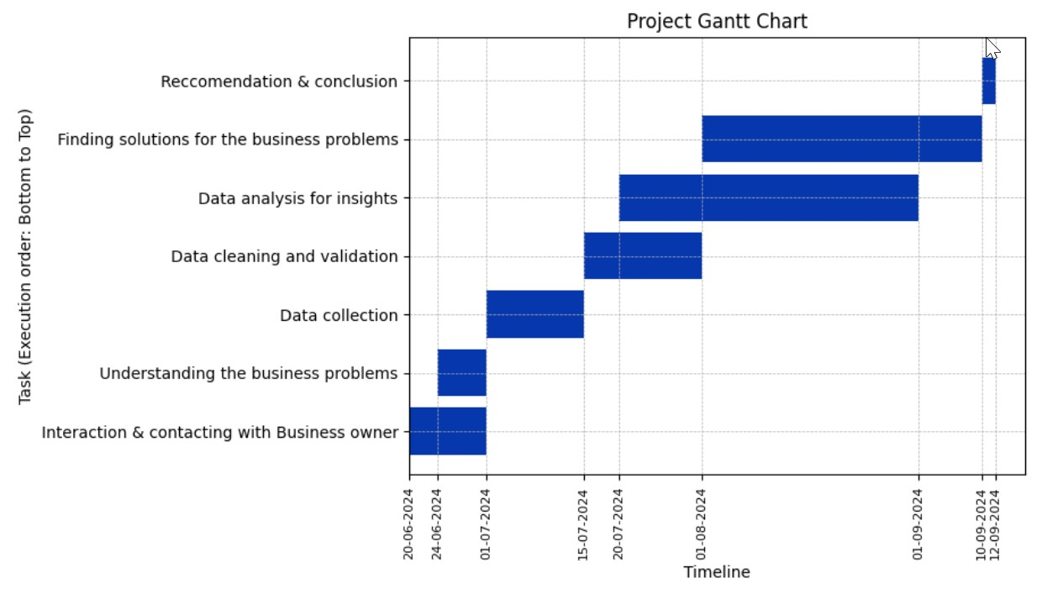

[**https://drive.google.com/file/d/1cvqE9ImrN7QgftAnVq6aToN8ZiV4Uv2C/view?usp=drive_link**](https://drive.google.com/file/d/1cvqE9ImrN7QgftAnVq6aToN8ZiV4Uv2C/view?usp=drive_link)

1. **Proof of originality**:

Primary data collected:

* Purchase records from 01-04-23 to 30-09-23.Link of image file :{{[Click here](https://github.com/BinayakEE2DS/BDM-capstone-Project/blob/main/BDM%20Project%20Files/Authorization%20and%20Evidences/Marg%20ERP%20Software%20Images/1.png)}}
* Sales records from 01-04-23 to 30-09-23. Link of image file :{{[Click here](https://github.com/BinayakEE2DS/BDM-capstone-Project/blob/main/BDM%20Project%20Files/Authorization%20and%20Evidences/Marg%20ERP%20Software%20Images/1.png)}}
* Video Interaction with shop owner: Link of video file :{{[Click here](https://drive.google.com/file/d/1lPmwx7F420GI1ityU7kzJB1CbHf4Dmya/view?usp=drive_link)}}

I have interacted with the owner of New Medica Mr. Somnath Das regarding business background, issues being faced in running the business, problem areas which, if sorted out, would help the business to compete better with local and online competitors etc.

**Fig 5.1: Letter from the organization (New Medica): Link: {{**[Click here](https://github.com/BinayakEE2DS/BDM-capstone-Project/blob/main/BDM%20Project%20Files/Authorization%20and%20Evidences/Authorization%20letter/Authorisation.png)**}}**

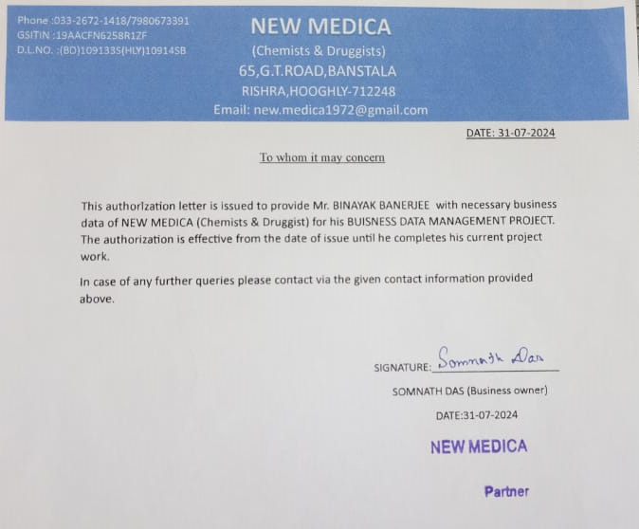

**Fig 5.2: Front view of the retail shop (New Medica): Link: {{**[Click here](https://github.com/BinayakEE2DS/BDM-capstone-Project/blob/main/BDM%20Project%20Files/Authorization%20and%20Evidences/Medica%20Images/Shop%20front.png)**}}**

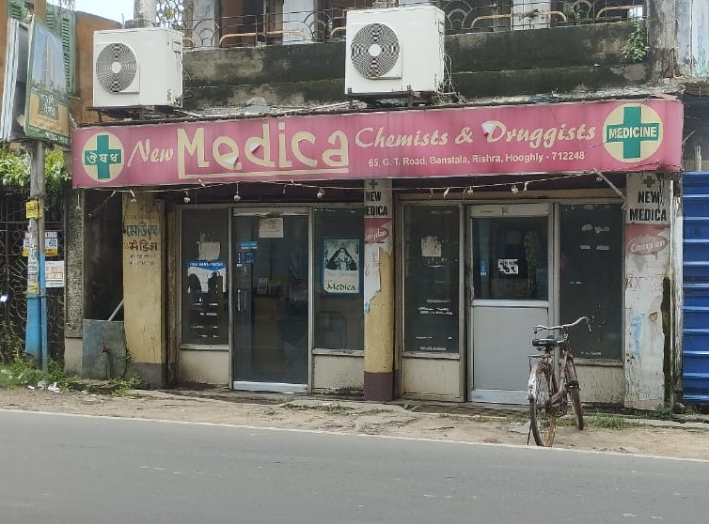

**Fig 5.3: Inside view of the retail shop (New Medica): Link: {{**[Click here](https://github.com/BinayakEE2DS/BDM-capstone-Project/blob/main/BDM%20Project%20Files/Authorization%20and%20Evidences/Medica%20Images/Shop%20inside.png)**}}**

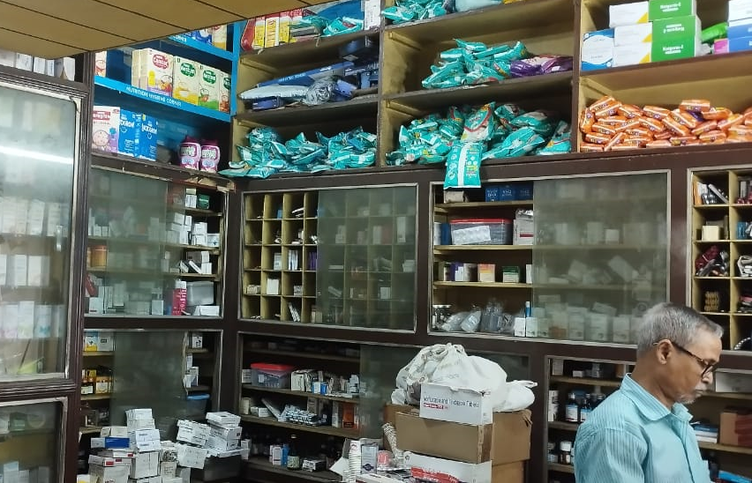

1. **Metadata and descriptive statistics:**
   1. **Metadata:**

Please refer to the excel file for metadata and descriptive statistics: {{[Click here](https://docs.google.com/spreadsheets/d/1GjvC72TTtW1uw26CQwQafzWhCgXtvIrI/edit?usp=drive_link&ouid=100949556449501882911&rtpof=true&sd=true)}}

The primary data in the referred excel file is contained in the sheets ‘**Purchase_data**’, ‘**Sales_data**’, ‘**April_data**’, ‘**May_data**’, ‘**June_data**’, ‘**July_data**’, ‘**August_data**’ & ‘**September_data**’

**Table 6.1:Metadata for the sheets ‘Purchase data’, ‘Sales_data’, ‘April_data’, ‘May_data’,‘June_data’,‘July_data’,‘August_data’ and ‘September_data’**





* 1. **Descriptive Statistics**:

**TABLE-6.2 : Descriptive statistics of purchase transaction data**

**TABLE-6.3: Descriptive statistics of sales transaction data**

**TABLE-6.4: Descriptive statistics of inventory data from April 2023 to September 2023**





1. **Detailed explanation of analysis process:**

**Flowchart of analysis process:**

* 1. **Data Collection:** Primary data has been collected from the purchase and sales bills obtained in the database of **Marg** - **ERP software** used in the shop. The process has been executed using Python to extract and aggregate data over the given study period out of the bills and produced into a CSV format. Similarly, the monthly item-wise inventory data has been extracted from the stock item database in the software which was originally presented in CSV format. After collecting the above data in CSV format, it was added into respective sheets as mentioned in metadata (refer **Table-6.1** in page **8**) of the excel file in xlsx format.
  2. **Data cleaning and preprocessing**: The primary data in each of the sheets had problems like white-spacing between strings, multiple space representation formats like character code -160 & character code-32, and improper datatype representation problems like date format represented in integer format. The quantity of items purchased / sold were represented in text format rather than integer format. All the above problems have been dealt with and column features have been converted into the required datatypes as mentioned in the metadata tables (refer **Table-6.1** in page **8** & page **9**). Furthermore, duplicate entries w.r.t. item name have been detected and deleted as part of the cleaning process.The data in current form has been used for various analysis process described.
  3. **Inventory Turnover ratio Analysis**:It is used to determine how quickly the shop sells and replaces its inventory over the study period. It reflects the efficiency of the inventory management system and provides insight into how well the shop is balancing its inventory with the customer demand.

**Equation 7.1:**

$$ITR=\frac{Cost of Goods Sold (COGS)}{Average Inventory }$$

where, **COGS**: The total (cost) purchase value of the inventory sold during the review period.

**Equation 7.2:**

$$Average inventory=\frac{Opening inentory value+Closing inventory value}{2}$$

where, **Average Inventory** is the average amount of inventory held during the period.

**High turnover ratio** indicates strong sales or effective inventory management by reducing holding costs. However, if too high, it may indicate understocking, which could lead to missed sales opportunities or stockouts.

**Low turnover ratio** indicates slow-moving inventory, potential overstocking, or weak sales. The business may be holding excess inventory, which ties up capital and increases storage costs. This inter-alia suggests the need for better inventory control or discounting slow-moving items.

Please refer to the excel file sheet named “**Consolidated inventory data** ” for the data of analysis process. Link:{{[Click here](https://docs.google.com/spreadsheets/d/1GjvC72TTtW1uw26CQwQafzWhCgXtvIrI/edit?usp=drive_link&ouid=100949556449501882911&rtpof=true&sd=true) }}

* 1. **Inventory Movement Categorization Analysis**: In order to perform a specific and result oriented analysis the items in the consolidated data have been segregated under following categories:
* **Non-moving items:** These are the items whose stock in hand are twice the average monthly purchases and total sales are **NIL.**
* **Slow-moving items:** These are the items whose stock in hand are twice the average monthly purchases and total sales are **not NIL.**
* **Fast-moving items:** These are the items whose **average monthly purchases** and **average monthly sales** are equal.
* **Remaining items:** Rest items in the total inventory not fulfilling the criteria of any one of the above three categories.

For detailed understanding of categories refer to **Table 8.2** in page no:**18** of the results and finding section.

* 1. **ABC Analysis:** ABC analysis is performed over the slow-moving items to further categorize items based on their capital blockage contributions.

**Procedure:** The items in the sheet has been arranged in descending order of capital blockage. A column for cumulative capital blockage has been generated containing the cumulative blockage contribution of the items in ascending manner. Consequently, cumulative capital blockage contributions of the items have been represented percentage-wise, which forms basis of the items being categorized as A, B & C.

Please refer to the excel file sheet named “**ABC slow moving items** ” for the data of analysis process. Link:{{[click here](https://docs.google.com/spreadsheets/d/1D3N3ED26BiIFDTVxMrOFOLwmjZOcDynQ/edit?usp=drive_link&ouid=100949556449501882911&rtpof=true&sd=true)}}

**Equation 7.3**:

$$Cumulative Capital Blockage of_\{t+1\}th item=Cumulative Capital Blockage of_\{t\}items+capital blockage of_\{t+1\}th item$$

​

Blockage contribution of the item categories have been described below:

**Category A**: Represents the top ‘x’ items contributing up to 70% of the capital blockage.

**Category B**: Represents the next ‘y’ items contributing up to next 20% of the capital blockage.

**Category C**: Represents the rest of the items contributing to remaining 10% of the capital blockage.

Interpretation of the ABC-Analysis: The analysis categorizes the slow-moving items further into three categories—A, B, and C. The categorization has been performed on the basis of their significance, typically measured by their contribution to overall capital blockage. The objective is to prioritize the management and control of inventory items by focusing on the most critical ones.

* 1. **Inventory risk assessment using stockout probabilities:**

The analysis allows to monitor categorized items based on risk associated for a stockout situation. Inventory risk assessment due to frequent stockout is performed on the fast-moving items. The analysis is used in further segmentation of fast moving items based on the percentage probabilities of stockout.

**Procedure:** Items have been categorized on the basis of monthly closing balance stockout cases i.e., the cases where monthly closing balance is zero. Probability of item stockout has been calculated from the monthly stockout cases. The counts and percentage- wise representation of items across the categories has been calculated.

Please refer to the excel file sheet named “ **Stockout monitoring** ” for the data of analysis process. Link:{{[click here](https://docs.google.com/spreadsheets/d/1D3N3ED26BiIFDTVxMrOFOLwmjZOcDynQ/edit?usp=drive_link&ouid=100949556449501882911&rtpof=true&sd=true)}}

**Equation 7.4:**

$$Probability\left(\%\right)of item stock out=\frac{(Number of monthly stock out cases*100)}{(Total number of months of review period)}$$

For example,

No. of monthly closing balance stock out cases=4

Item category=D

Total number of months of review period=6

$Probability(\%)of item stockout =(4*100)/6=67\%$

Interpretation of percentage probability of stockouts: Each of the item categorization has a definite value of monthly stockout case associated to it resulting into a particular percentage probability of item stockout. Increasing order of percentage probability of stockout represents item categories with high risk of facing stockout situation and vice-versa.

* 1. **ABC-XYZ Analysis**: The analysis categorizes items based on their importance in terms of value as well as demand stability, leading to improved item demand forecasting and inventory planning. The analysis process also helps in achieving efficient resource allocation.

The ABC-XYZ analysis is performed on the items of the category ‘remaining items’. As the name suggests the analysis comprises of two parts -ABC analysis and the XYZ analysis. ABC analysis classifies inventory into three categories based on their importance in terms of sales value generated. It helps businesses prioritize resources toward the most sales value generating items. XYZ analysis classifies inventory based on the variability of demand or consumption.

Please refer to the excel file sheet named **“ ABC - XYZ** ” for the data of analysis process. Link:{{[click here](https://docs.google.com/spreadsheets/d/1D3N3ED26BiIFDTVxMrOFOLwmjZOcDynQ/edit?usp=drive_link&ouid=100949556449501882911&rtpof=true&sd=true)}}

**Procedure:** For categorizing items as **A,B** and **C** using **ABC analysis** items in the sheet has been arranged in descending order of sales value. A column for cumulative sales value has been generated containing the cumulative sales value of the items in ascending manner. Consequently, cumulative sales value contributions of the items have been represented percentagewise based on which the items have been categorized.

* **Category A**: Represents the top ‘x’ items contributing up to 70% of the overall sales value.
* **Category B**: Represents the next ‘y’ items contributing up to next 20% of the overall sales value.
* **Category C**: Represents the rest of the items contributing to remaining 10% of the overall sales value.

For categorizing items as **X, Y** and **Z** using **XYZ analysis**, standard deviation of the sales quantity over the review period has been calculated. The variability in sales demand of items has been calculated using coefficient of variation. The items have been categorized on the basis of coefficient of variation expressed percentage-wise which represents the uncertainty level of sales for the item.

* **Category X**: These have a consistent demand or consumption rate with minimal fluctuations, making them easier to forecast. For the category of items percentage coefficient of variation ranges from [**0,25**).
* **Category Y**: These have moderate fluctuations in demand or consumption, with some level of seasonality or trend-based changes. For the category of items percentage coefficient of variation ranges from [**25,40**).
* **Category Z**: These have irregular or unpredictable demand patterns, making forecasting difficult. For the category of items percentage coefficient of variation ranges from [**40,224(max. value)**).

**Equation 7.5:**

$$Cumulative sales value of_\{t+1\}th item=Cumulative sales value of_\{t\}th item+sales value of_\{t+1\}th item$$

**Equation 7.6:**

$$Population standard deviation\left(σ\right)=\frac{1}{N}\sqrt{\sum{{(x}_{i}-μ)^2 }}$$

Where, N=size of population

$x_i$ =Sample value from the population

$μ=$ Mean of the population

**Equation 7.7:**

$$Coefficient of variation (CV)=σ/μ$$

Where, $σ=$ population standard deviation

$μ=$ Mean of the population

The items have been categorized into the following categories listed below:

* **Category AX**: High-value items with consistent demand.
* **Category AY**: High-value items with fluctuating demand.
* **Category AZ**: High-value items with unpredictable demand.
* **Category BX, BY, BZ**: Moderate-value items with different demand patterns.
* **Category CX, CY, CZ**: Low-value items with various demand patterns

For detailed understanding of categories refer to table 8.7 in the results and finding section.

1. **Results and findings**:
   1. **Results and findings from inventory turnover ratio analysis (ref: section 7.1):** Please refer to the excel file sheet named “**consolidated inventory data**” for finding tables and fig attached below. Link:{{[Click here](https://docs.google.com/spreadsheets/d/1GjvC72TTtW1uw26CQwQafzWhCgXtvIrI/edit?usp=drive_link&ouid=100949556449501882911&rtpof=true&sd=true)}}

On carrying out analysis over the consolidated inventory data using inventory turnover ratio items were categorized with different ranges of ITR values. For the classified item categories data for item counts, percentage of inventory, purchase value, sales value ,capital blockage and percentage of capital blockage has been extracted and arranged in the form a table named “**ITR Range Analysis by item Category**”. The details of the inventory turnover ratio analysis on the consolidated inventory data is shown in **Table-8.1**.Using the data available from the table we have plotted the charts shown in **Fig-8.1** & **8.2**.

**Table-8.1: ITR Range Analysis by Item Category**



**Fig-8.1: Item Distribution and Inventory Percentage**

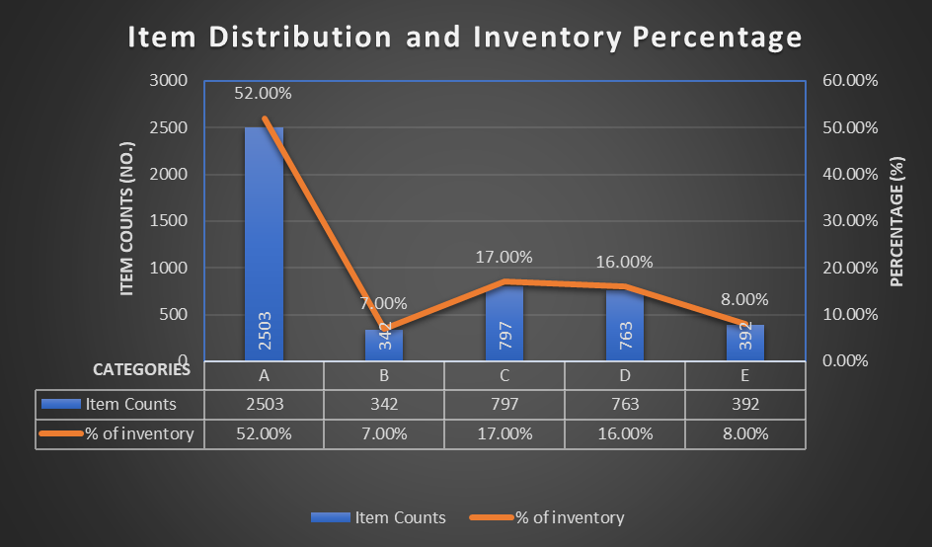

**Fig-8.2: Purchase, Sales, and Capital Blockage Comparison**

* + 1. **Inventory Turnover Ratio (ITR) Range Categorization**:
* **Category A** (ITR range [**0,0.25**)) contains **2503** items, making up **52%** of the inventory. These items have a high capital blockage (**₹12,48154.49**), accounting for **91%** blockage. This indicates slow-moving or stagnant inventory tying up significant capital.
* **Category B** (ITR range [**0.25,0.5**)) has **342** items, which represent **7%** of the inventory and face a **77%** capital blockage. These items also pose a capital concern but to a lesser extent than Category A.
* **Category C** (ITR range [**0.5,1**)) consists of **797** items, comprising **17%** of the inventory, with 0% capital blockage. These items seem to perform well with no capital block.
* **Category D** (ITR range [**1,3**)) holds **763** items, making up **16%** of the inventory and has **5%** capital blockage, a relatively healthier turnover ratio.
* **Category E** (ITR range [**3, very high value**)) with **392** items forms 8% of the inventory and shows **0%** capital blockage. These are fast-moving items with efficient capital utilization.
  + 1. **Purchase and Sales Value:** 
       - **Category A** shows a large gap between purchase value (₹**13,74,212.09**) and sales value (**₹1,26,057.6**), which highlights the low turnover and excessive stock holding.
       - **Category B** has a purchase value of **₹3,69,128.93** and a sales value of **₹84,623.87**, which also shows a discrepancy but with a reduced blockage.
       - **Categories** **C, D**, and **E** display much more balanced purchase and sales values, indicating these items are contributing positively to turnover and profitability, with no major capital blockage.
    2. **Capital Blockage Insights:**
  + Capital blockage is highest in **Category A** (**₹12,48154.49**) and **Category** **B** (₹**2,84,505.06**), which can severely affect liquidity and cash flow.
  + **Categories** **C, D**, and **E** have negligible or no capital blockage, suggesting efficient stock management and sales.
    1. **Key Findings:**
* **High Capital Blockage in Low ITR Categories (A and B):**

Items in Category A are holding up a significant portion of capital (**91%**), contributing to very slow movement and sales. These need urgent attention, such as promotional strategies, discounts, or even discontinuing less-demanded items. Similarly, Category B items, though smaller in count and percentage, still exhibit a **77%** capital blockage, demanding more efficient stock handling.

* **Healthy Performance in Categories C, D, and E:**

**Categories** **C, D,** and **E** reflect optimal inventory turnover and low or zero capital blockage. This suggests that these categories are driving profitability and efficient resource utilization. Special emphasis can be placed on ensuring stock availability in these categories to boost sales.

* **Resource Mobilization and Profitability:**

The findings suggest that New Medica's profitability and resource mobilization are impacted primarily by overstocked and slow-moving items. Addressing these categories will significantly improve cash flow and reduce blocked capital.

* 1. **Results and findings from inventory movement categorization analysis (ref: section 7.2):** Please refer to the excel file sheet named “**Tables and charts**” for finding tables and fig attached below. Link:{{[Click here](https://docs.google.com/spreadsheets/d/1D3N3ED26BiIFDTVxMrOFOLwmjZOcDynQ/edit?usp=drive_link&ouid=100949556449501882911&rtpof=true&sd=true)}}

**Table 8.2: Criteria for item categorization of consolidated inventory data**

**Table:8.3 Category-wise item distribution and value analysis**

**Fig-8.3: Category-wise item count**

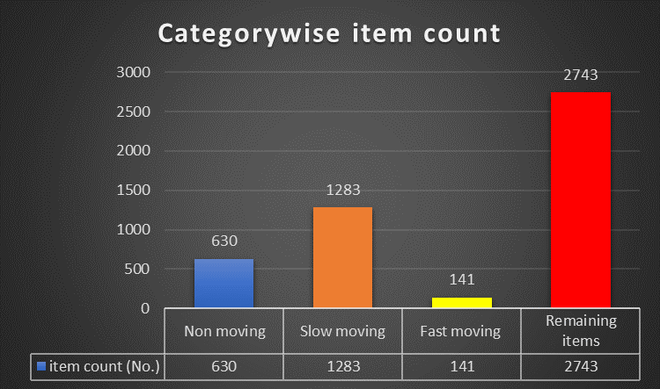

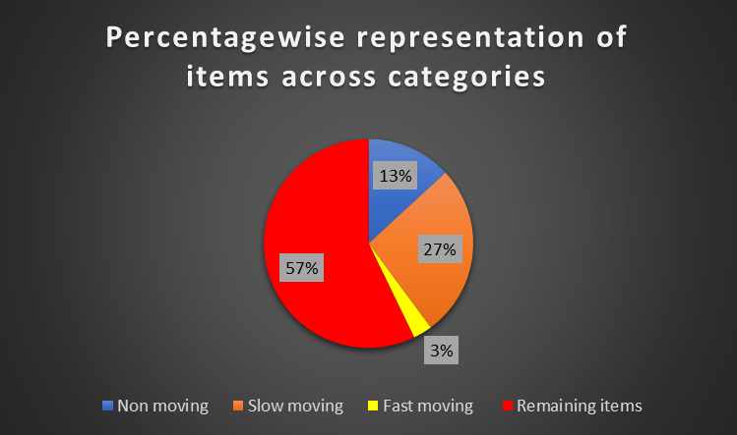**Fig-8.4 : Percentage wise representation of items across categories**

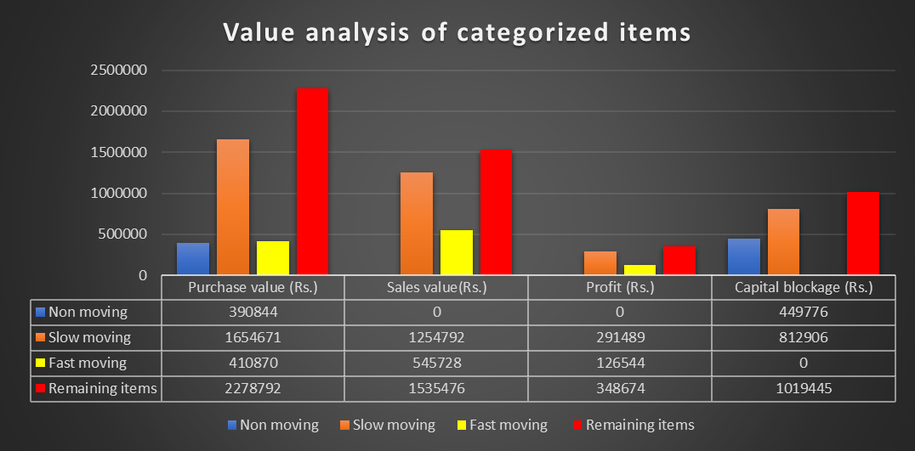**Fig-8.5: Value analysis of categorized items**

**Table 8.4: Capital flow analysis across item categories**

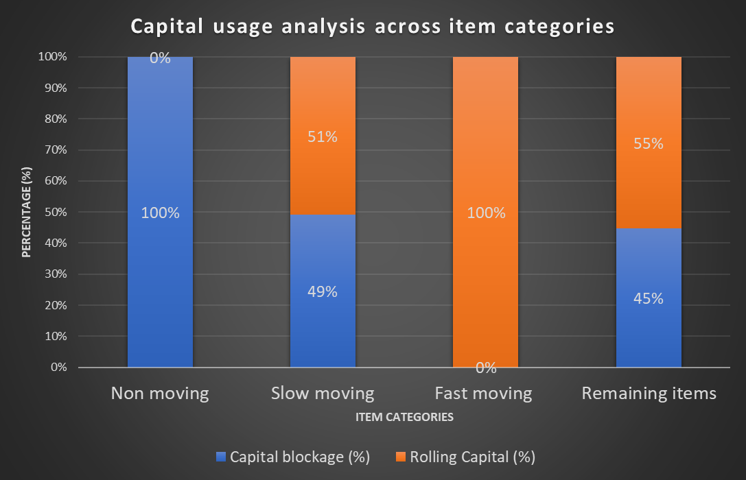**Fig-8.6: Capital usage analysis across item categories**

**Fig- 8.7: Capital blockage contribution per item**

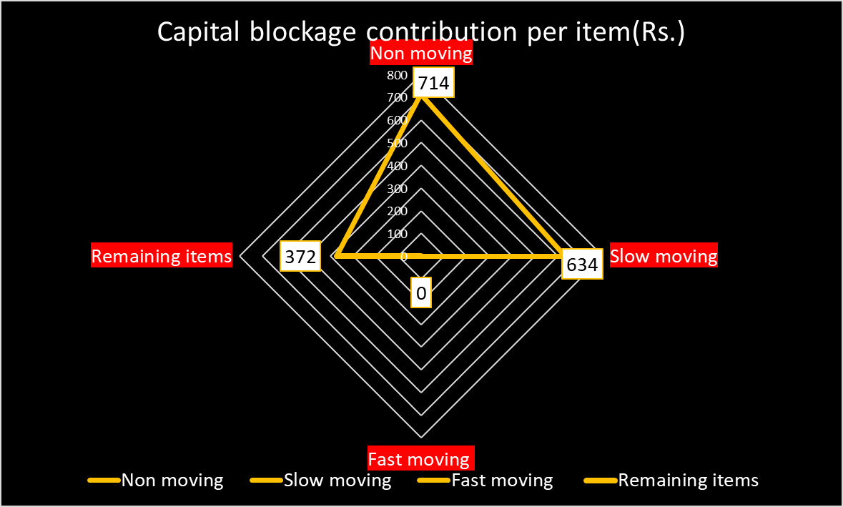

* + 1. **Item Category Distribution**:
* **Non-Moving Items**: There are **630 non-moving items**, representing **13%** of the total inventory volume. These items have a purchase value of **₹3,90,844** and currently generate no sales or profit. The capital blockage tied to these items is **₹4,49,776**, indicating a significant resource allocation issue.
* **Slow-Moving Items**: There are **1,283 slow-moving items**, which make up **27%** of the total volume. This category shows a purchase value of **₹1,654,671** and sales value of **₹1,254,792**, generating a profit of **₹291,489**. However, the capital blockage is high, amounting to **₹8,12,906**.
* **Fast-Moving Items**: A total of **141 fast-moving items** account for only **3%** of the total inventory volume. These items have a purchase value of **₹4,10,870**, a sales value of **₹5,45,728**, and have generated a profit of **₹1,26,544**. No capital blockage is observed for this category.
* **Remaining Items**: This is the largest category, comprising **2,743 items** (approximately **57%** of the total volume). These items have a purchase value of **₹2,278,792** and have contributed to sales worth **₹1,535,476**, yielding a profit of **₹348,674**. However, the capital blockage remains significant at **₹1,019,445**.
  + 1. **Capital Blockage Contribution per Item**:
* The **radar chart** shows that non-moving items have the **highest capital blockage per item (₹714)**, followed by slow-moving items (**₹634**). **Fast-moving items** contribute nothing to capital blockage, while remaining items have the lowest blockage contribution per item at **₹372**. The **non-moving and slow-moving categories** clearly have more capital tied up per item, which indicates inefficiency in managing inventory for these items.
  + 1. **Rolling Capital Efficiency**:
* **Non-moving items** represent the most inefficient category, with **100% capital blockage** and no rolling capital, reflecting poor return on investment for this group.
* **Slow-moving items** have a balanced distribution between capital blockage (**49%**) and rolling capital (**51%**). However, the high blockage portion shows that there's room to improve inventory turnover.
* **Fast-moving items** have **100% rolling capital**, meaning that the capital tied to these items is being effectively utilized to generate revenue.
* The **remaining items** have a similar situation to slow-moving items, with **45% capital blockage** and **55% rolling capital**, indicating moderate efficiency.
  + 1. **Net Capital Usage**:
* **Slow-moving** items have a net capital usage of **₹1,654,671**, with a mix of rolling and blocked capital. This signifies the need for measures to increase inventory movement and reduce blockage.
* **Remaining items** have the highest net capital usage at **₹2,278,792**, but nearly half of this is locked up in non-performing inventory.
* **Fast-moving items** demonstrate the most efficient net capital usage with **₹410,870** in rolling capital.
  + 1. **Sales and Profit Analysis**:
* **Non-Moving Category**: No sales have been recorded in this category, leading to **zero profit** and the largest capital blockage.
* **Slow-Moving Category**: This category, though contributing to sales and profit, has a considerable gap between the purchase value and sales, leading to moderate profit margins and high capital blockage.
* **Fast-Moving Category**: This is the most efficient category, with higher sales relative to the purchase value and no capital blockage. The profit percentage here is substantial, indicating good demand and high turnover.
* **Remaining Items**: Items for the category generate profit, the high capital blockage and needs to be managed better by focusing on efficient stock management.
  1. **Results and findings from ABC analysis (ref: section 7.3):** Please refer to the excel file sheet named “**ABC slow moving items**” for finding tables and fig attached below. Link:{{[Click here](https://docs.google.com/spreadsheets/d/1D3N3ED26BiIFDTVxMrOFOLwmjZOcDynQ/edit?usp=drive_link&ouid=100949556449501882911&rtpof=true&sd=true)}}

**Table-8.5: Calculation of capital blockage contribution of slow-moving items**



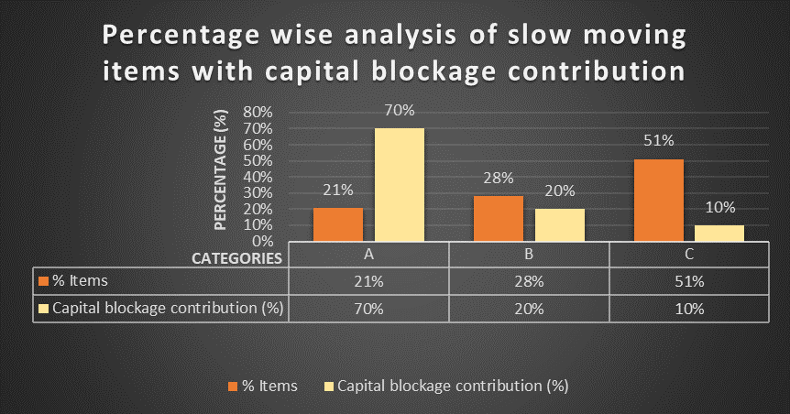**Fig-8.8: Percentage wise analysis of slow-moving items with capital blockage contribution**

* + 1. **Item Categories and Capital Blockage Contribution**:
* **Category A**: Items in this category account for **21%** of the total slow-moving items, with **267 items**. However, they contribute **70% of the capital blockage**, amounting to a massive **₹5,69,033.85**. Items within the category should be the **top priority** for inventory optimization. The high capital blockage in this category, despite the smaller number of items, suggests that there is a significant amount of capital tied up in these items, potentially resulting in reduced liquidity and profitability. These items likely have a high individual cost and low turnover rate.
* **Category B**: Category B represents **28% of the total slow-moving items** (360 items), contributing **20% of the capital blockage**. The capital blockage **contribution in this category is ₹1,62,581.1. Items in Category B have a** moderate capital blockage impact, but they still hold significant value that could be freed up through appropriate measures.
* **Category C**: This category contains the largest number of items, representing **51% of the slow-moving inventory** (**656 items**). However, they contribute only **10% of the capital blockage**, amounting to **₹81,290.55**. Despite having the most items, the capital blockage contribution per item is the lowest, indicating that this category is less critical in terms of capital inefficiency.
  1. **Results and findings from inventory risk assessment analysis using stockout probabilities (ref: section 7.4):** Please refer to the excel file sheet named “**Stock out monitoring**” for finding tables and fig attached below. Link:{{[Click here](https://docs.google.com/spreadsheets/d/1D3N3ED26BiIFDTVxMrOFOLwmjZOcDynQ/edit?usp=drive_link&ouid=100949556449501882911&rtpof=true&sd=true)}}

**Table-8.6:Calculation of stock out probabilities across fast-moving items**

**Fig-8.9: Fast moving item distribution based on percentage probability of stockout**

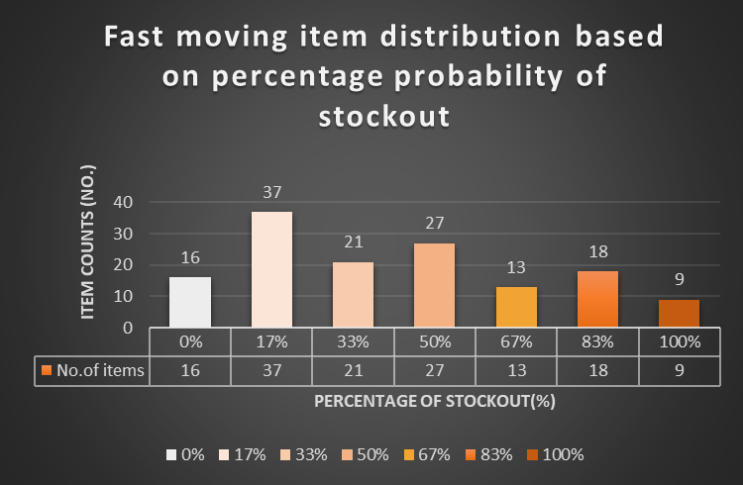

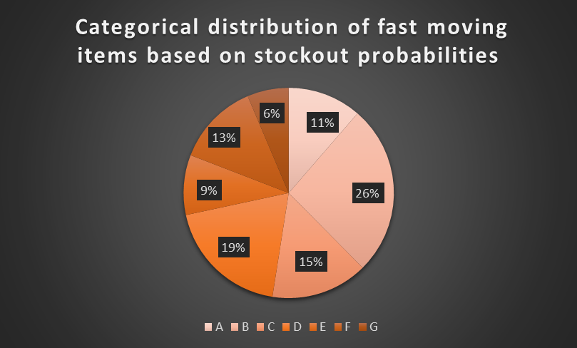**Fig-8.10: Categorical distribution of fast-moving items based on stock out probabilities**

* + 1. **Stockout Probability Distribution**:
* **A category (0% probability)**: Out of the **141** fast-moving items, **16** items (**11%**) have **zero probability** of stockout. These items are well-managed in terms of inventory, with sufficient stock to meet demand without risk of shortage.
* **B category (17% probability)**: **37** items (**26%**) have a moderate risk of stockout. This category represents items that may experience occasional shortages, requiring moderate attention.
* **C category (33% probability)**: **21** items (**15%**) fall into a higher risk of stockout, necessitating tighter inventory management practices to avoid lost sales.
* **D category (50% probability)**: **27** items (**19%**) have a 50% chance of stockout, representing a critical point for intervention to prevent frequent shortages.
* **E category (67% probability)**: **13** items (**9%**) have a higher likelihood of stockout, posing a significant risk to maintaining customer satisfaction and sales continuity.
* **F category (83% probability)**: **18** items (**13%**) are at a very high risk of stockout, signaling an urgent need for better inventory replenishment processes.
* **G category (100% probability)**: **9** items (**6%**) have a certain risk of stockout. These items will always face shortages unless immediate corrective actions are taken.
  + 1. **Key insights:**
* More than half of the items (**55%**) fall within the moderate to high-risk categories (**B to D**), indicating a need for stronger inventory management and restocking procedures.
* A small portion of items (**6%**) in **G category** has a guaranteed stockout issue, requiring immediate intervention to prevent customer dissatisfaction and lost sales.
* **Low-risk items** (**A and B**) represent **37%** of the total fast-moving items. These could be examples of well-maintained inventory practices, but they should still be monitored to avoid slipping into higher-risk categories.
  1. **Results and findings from ABC-XYZ analysis (ref: section 7.5):** Please refer to the excel file sheet named “**ABC-XYZ**” for finding tables and fig attached below. Link:{{[Click here](https://docs.google.com/spreadsheets/d/1D3N3ED26BiIFDTVxMrOFOLwmjZOcDynQ/edit?usp=drive_link&ouid=100949556449501882911&rtpof=true&sd=true)}}

**Table-8.7: Significance of item categories in ABC-XYZ analysis**

**Table-8.8:** **Distribution of items across categories**

**Table-8.9: Percentage wise distribution of items across categories**



**Table-8.10:** **Inventory Management Strategy Matrix Based on ABC-XYZ Analysis**

**Table-8.11: Summary of value analysis of A, B & C categories**

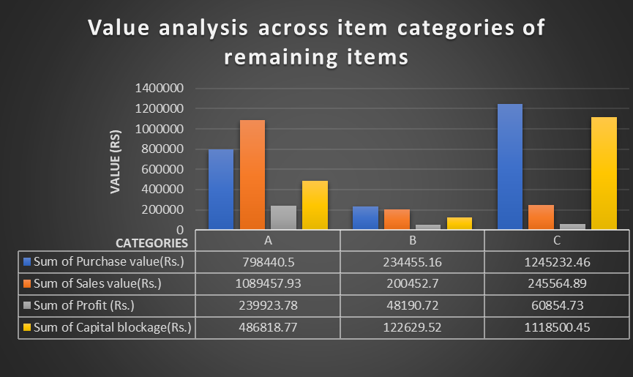**Fig-8.11: Value analysis across item categories of remaining items**

* + 1. **Volume and Stability Insights:**
* **Category A:** This category (High-value items) has **197 items** (**42** in **X**, **62** in **Y**, and **93** in **Z**). A majority of these are high sales volume items but they differ in their demand stability.
* **Category AX**: Comprises of **(42 items)** which has high volume and stable sales, ideal for automated replenishment with regular safety stock management.
* **Category AZ:** Comprises of **(93 items)** which has high volume but very fluctuating demand, requiring close monitoring and frequent adjustments to inventory levels.
* **Category B:** (Medium-value items) includes **118 items** (**19** in **X**, **35** in **Y**, **64** in **Z**). While B category items have lower volumes, **Z (64 items)** shows significant demand fluctuation, so these items require careful monitoring and stock control to avoid excess.
* **Category C:** (Low-value items) dominates the remaining inventory with 2,428 items (**1605** in **X**, **1** in **Y**, and **822** in **Z**).
* **Category CX:** **1605 items** are in this category **(low volume and stable)**, showing little fluctuation but contributing significantly to overall stock count.
* **Category CZ: (822 items)** in this category is concerning, as these items have high fluctuation, requiring careful analysis to avoid excess inventory.
  + 1. **Value Contribution by Categories:**
* **Total Purchase Value** across all categories: **Rs.2,278,128.12**.
* **Category A** has a net purchase value of **Rs 798,440.5** and items of this category generate the most profit (**Rs.2,39,923.78**) despite having fewer items (**197**).
* **Category C** has the highest purchase (**Rs.12,45,232.46**) and sales value (**Rs.2,45,564.89**) but a much lower profit contribution (**Rs.60,854.73**), suggesting lower profitability per item compared to Category A. It has the highest capital blockage (**Rs.11,18,500.45**), indicating that a large amount of capital is tied up in these low-volume, fluctuating items.
  + 1. **Percentage of Items by Volume and Uncertainty (Heatmap Analysis):**
* **Category A:** Represents **1%-2%** of the total items and requires similar care but not as aggressive inventory management compared to Category A. Since this category consists of high-value, high-profit items, it should be prioritized for automation and frequent monitoring to ensure supply meets demand.
* **Category B:** Represents **1%-2%** of the total items and requires similar care but not as aggressive inventory management compared to Category A.
* **Category C:** Constitutes the largest percentage (**59%** in **X** and **30%** in **Z**), meaning a significant amount of stock consists of low-value, fluctuating items. Since these items tie up large amounts of capital but offer lower returns, inventory should be minimized through better forecasting and frequent stock monitoring to reduce wastage and excess holding costs

1. **Interpretation of results and recommendations:**
   1. **Recommendations based on item categories:**
      1. **Non-Moving Items (13% of total volume):**

* **Immediate Action:** Focus on liquidating non-moving items to free up capital **(₹4,49,776**) currently blocked. Implement strategies like deep discounts, promotional sales, or return policies to move these items quickly.
* **Supplier Negotiation:** Explore possibilities for returning non-moving items to suppliers or exchanging them for more fast-moving inventory.
  + 1. **Slow-Moving Items (27% of total volume):**
* **Targeted Promotions:** Use targeted marketing campaigns (discounts, bundle offers) to improve turnover and reduce stockholding costs. These items generate some profit (**₹2,91,489**) but suffer from high capital blockage (**₹8,12,906**).
* **Capital Reduction:** Prioritize reducing stock levels in Category A slow-moving items (**21%** of items contributing **70%** of capital blockage). Implement aggressive promotional strategies and explore liquidation options where necessary.
  + 1. **Fast-Moving Items (3% of total volume):**
* **Monitor Stockout Risks:** Focus on categories **D, E, F**, and **G** (high to critical stockout risk) for continuous inventory replenishment to avoid lost sales. Strengthen predictive demand analytics to ensure uninterrupted stock availability.
* **Automated Replenishment:** Use automated replenishment systems for fast-moving items with a low probability of stockouts (Categories **A** and **B**) to maintain stock levels efficiently.
  + 1. **Remaining Items (57% of total volume):**
* **Inventory Optimization:** Streamline stock management for remaining items, which show high capital blockage (**₹1,019,445**). These items generate moderate profit but need more efficient resource allocation to improve profitability and liquidity.
* **Sales Promotion:** Implement moderate promotions for items in this category to reduce overstocking and improve turnover.
  1. **Capital Blockage Reduction:**
     1. **Priority Action:** Category A of slow-moving items and Category C of remaining items contribute to significant capital blockage. Immediate attention should be given to freeing up capital by reducing stock levels in these categories through targeted promotional activities, supplier negotiations, or stock liquidation.
     2. **Minimize Overstocking:** Focus on minimizing overstocking in Category C (low-value, high-fluctuation items) and redistributing resources towards more profitable, high-sales volume items in Category A of remaining items.
  2. **Inventory Risk Management for Fast-Moving Items:**
     1. **Critical Stockout Prevention:** Address the high risk of stockouts in categories **D, E, F**, and **G**. Replenishment planning, supplier negotiations, and predictive analytics should be employed to prevent stockouts and ensure customer satisfaction.
     2. **Monitor Low-Risk Items:** Although categories A and B (**37%** of items) have a low risk of stockouts, they should still be monitored regularly to prevent any potential shortages.
  3. **ABC-XYZ Analysis-Based Strategies:**
     1. **Automate Replenishment for High-Value Items (Category A, X):** Automate replenishment processes for items with high value and stable demand to ensure optimal inventory levels.
     2. **Reduce Overstocking in Low-Value, Fluctuating Items (Category C, Z):** Closely monitor items in Category C with fluctuating demand. Reduce stock levels of these items and optimize inventory to prevent unnecessary capital blockage.
     3. **Dynamic Pricing for Fluctuating Demand (Category B, Z):** Implement dynamic pricing and promotional campaigns for Category **B** items with fluctuating demand to boost sales without excessive discounting.
  4. **Overall Strategy:**
     1. **Inventory Efficiency:** Focus on reducing stock in non-moving and slow-moving items to free up capital and improve liquidity. Promote efficient inventory turnover in fast-moving and remaining items through better demand forecasting and stock replenishment.
     2. **Resource Mobilization:** Redistribute capital from non-moving and low-profit items to fast-moving, high-profit items to boost profitability.
     3. **Growth and Profitability:** By improving stock rotation, reducing stockouts, and managing inventory effectively, New Medica can enhance profitability, customer satisfaction, and overall business growth.

1. 4.1.2